February 27, 2018

This Danish Family Is Taking On the World Brick by Brick

The seventh generation of Petersens are responsible for some of today’s most architecturally significant—and compelling—structures

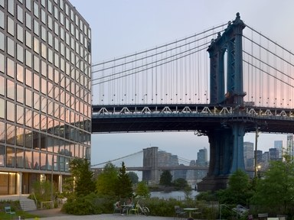
A Petersen-brick building, at left, in New York. Photo: Tom Eckerle

“We have three principles that we abide by,” says Christian A. Petersen, the seventh generation member of the Danish family behind Petersen Brick. “The customer is king; Der Kunde ist König and Le client est roi.” Multiple translations, but one ethos: to tailor brick production to any project, no matter how ambitious, or where it might be. Founded in 1791, Petersen Brick has based itself in a site of rich clay deposits beside the navigable Baltic Sea, which has allowed its bricks to find markets across Northern Europe. Not only are the bricks durable in exposed northerly locations, but also they are versatile in terms of any design aesthetic desired. The product range—notably including the long, thin Kolumba brick, based on a Roman design—is now found in 43 countries and 12 U.S. states. How does Petersen manage it all at the age of 76? “Optimism, red wine, and the sanctuary of my fishing trawler,” he says with a laugh.
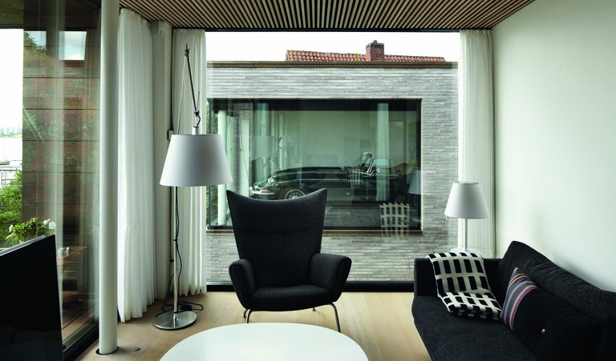
Photo: Anders Sune Berg

A villa in Kolding, Denmark.

A London project opting for Petersen’s bricks is the Turnmill building, located in Clerkenwell, an area of former warehouses. “We needed a façade material that was both sensitive to the historic setting—reflecting the sturdy masonry characteristics of the area—yet also strikingly contemporary,” explains architect Stuart Piercy. “We worked closely with Petersen Brick, visiting their brickworks in Denmark several times. They created special molds, 27 shapes in total, enabling us to realize the curved forms of the design. Together, we put a great deal of effort into making sure the brick color that was mixed in Denmark was right for London, for the Danish light is so different to London's softer light."
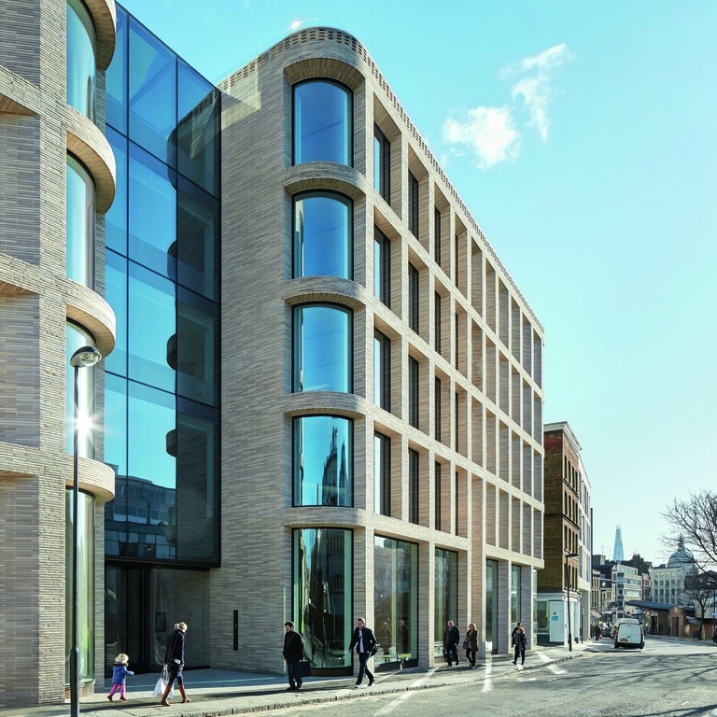
Photo: Hufton & Crow

Turnmill building, London.

In New York, brick is increasingly being chosen for exciting new buildings. A luxury condominium project at 180 East 88th Street, inspired by the boom in high-rise masonry construction during the 1920s and 1930s, will require 600,000 Petersen bricks. High-profile projects using the bricks are also underway at 150 Wooster Street in SoHo, and 145 President in the heart of “Brownstone Brooklyn.” Nearby in Brooklyn is 211 Schermerhorn, a modern take on New York’s classic brick apartment buildings.
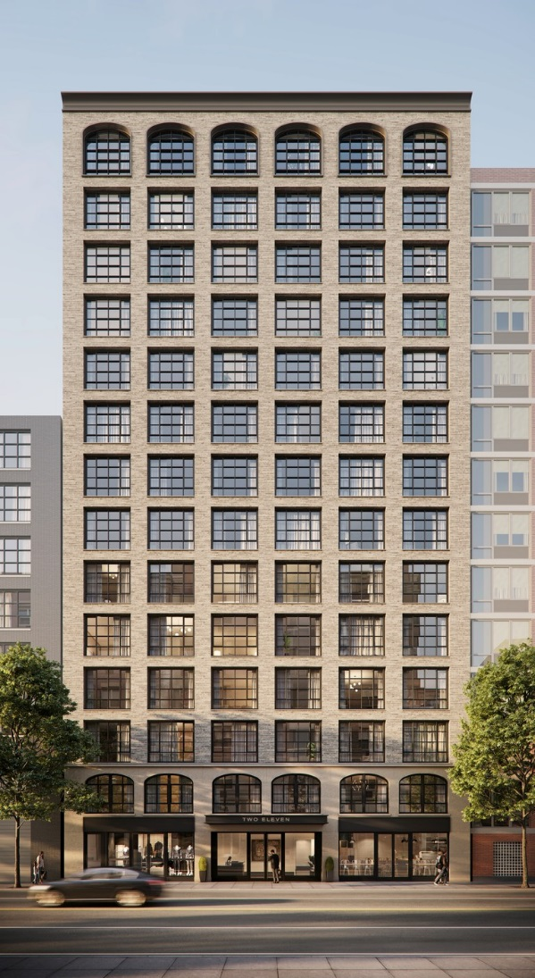
Photo: Arc Media

211 Schermerhorn, Brooklyn.

“We’re working at the relatively intimate scale of 14 stories,” explains Morris Adjmi, founder of Morris Adjmi Architects. “It’s a clean, contemporary design with large industrial-inspired windows punching through a textured façade of handcrafted Petersen brick. We always look to a neighborhood’s character and history for inspiration. Boerum Hill has such a rich heritage with its tree-lined streets and historic brownstones, and Schermerhorn Street itself was named after a Dutch shipping family that settled here in the 1790s. So sourcing these beautiful materials from northern Europe just felt right.” The building opens in 2019.

