May 18, 2018

Author Norman Mailer's Brooklyn Heights co-op lists at $2.4M

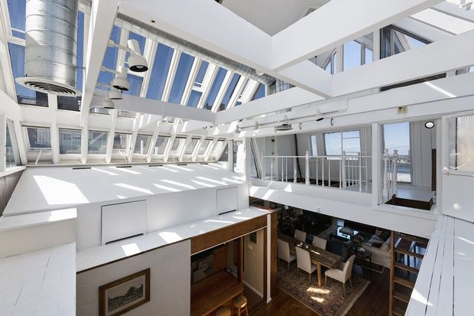

Author Norman Mailer’s nautically themed space in Brooklyn Heights was built in 1840.

See the listing on CORE here

Photo Credit: Rich Caplan for CORE
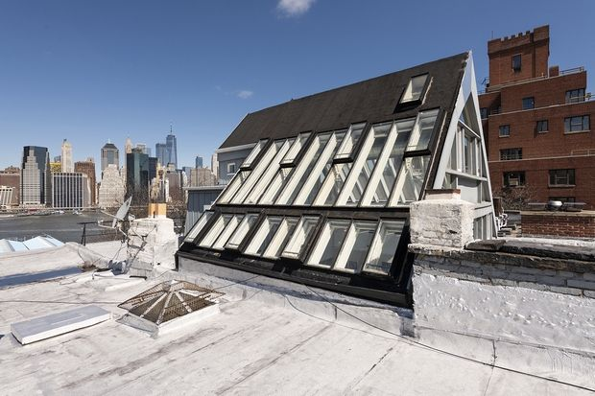

142 Columbia Heights is a landmarked four-story, walk-up brownstone

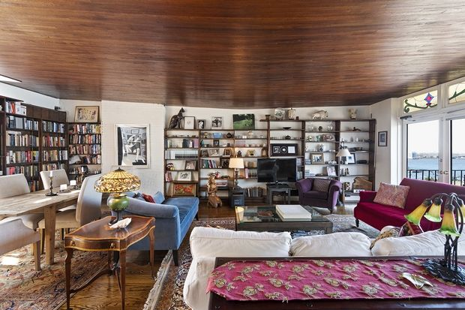

The home has a two-story glass and wood atrium and a sloping wood ceiling.
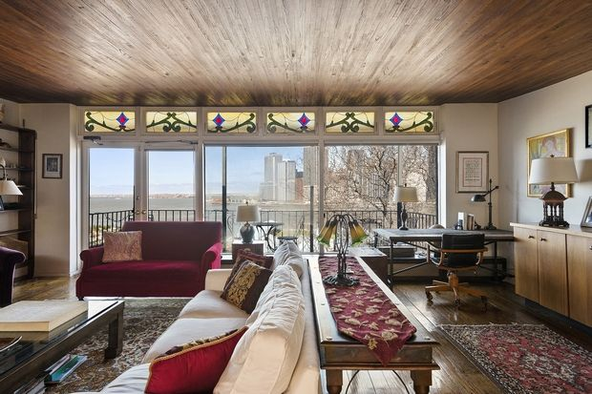

There are multiple outdoor terraces overlooking the Brooklyn Bridge Park and the Statue of Liberty.

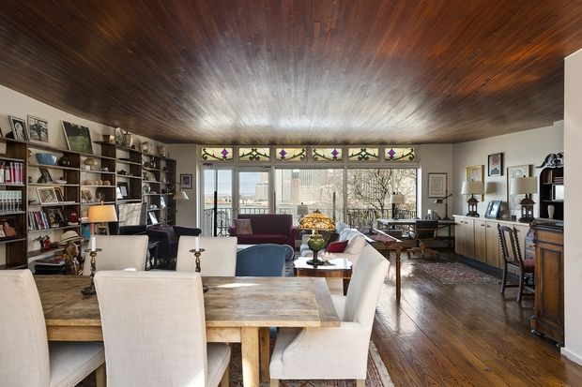

The space is approximately 1636 interior square feet
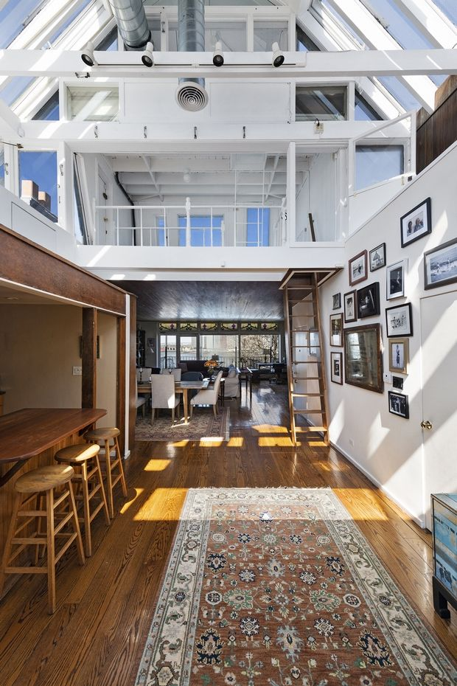

The home has three bedrooms and two bathrooms
